Failsafe pathway for BCG risk assessment on NIPE S4N system following the introduction of SCID evaluation
Patient Information Leaflet
What is severe combined immunodeficiency disease (SCID)?
• SCID is a group of rare, usually recessively inherited conditions that cause major immune
system problems
• Leads to reduced and malfunctioning T and B lymphocytes, which are the specialist white blood
cells made in the bone marrow and the thymus gland to fight infection

Incidence

• About 1 in 40,000 babies born in England have SCID - 14 babies per year
• SCID is more common when parents are related to each other
• Babies can have SCID when there is no family history
• Currently, about 30% of babies are identified by family history
• The delay in finding the remaining 70% means that they have been exposed to infection for longer
before receiving treatment, and could be very sick

SCID Screening Areas

The SCID evaluation will commence on 6 September 2021 and will take place over a 2 year period. Great Ormond street laboratory will be undertaking the evaluation in our region of Bedfordshire.

BCG Immunisation
BCG vaccination is recommended for babies up to 1 year old who:
• are born in areas of the UK where TB rates are higher than
in the rest of the country
• have a parent or grandparent who was born in a country
where there’s a high rate of TB
• BCG is a live vaccine, so giving this to a baby who has an
Immune condition can:
➢ cause severe side effects
➢cause complications for SCID treatment
➢increase morbidity and mortality rates

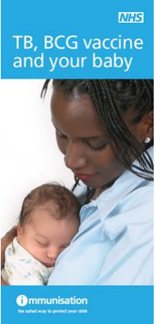
https://www.gov.uk/government/publications/scid-screening-helping-you-decide-if-you-want-this-for-your-baby/scid-screening-helping-you-decide
https://www.gov.uk/government/publications/screening-tests-for-you-and-your-baby

Please find below useful links for information and guidance also available in other languages

BCG Immunisation – change in practice
• From 1 September 2021, the BCG vaccine will be offered at 4 weeks of age where indicated.
SM/acd/SCIDPatientinformationleaflet/v1

