Sign 4 Little Talkers overview 2016
Sign 4 Little Talkers forms a part of the Sign 4 Learning suite of materials written to address gaps in attainment as identified by national data.
Sign 4 Learning is an initiative unique to Luton that successfully uses signs taken from British Sign Language to support understanding and language development in hearing children. It was written and trialled in Luton and has been showcased in National publications and National, European and International conferences.
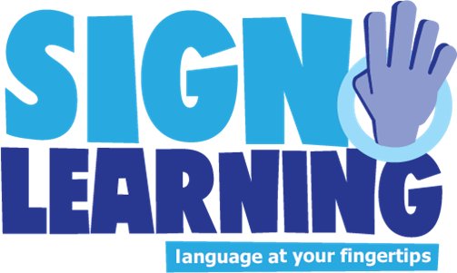

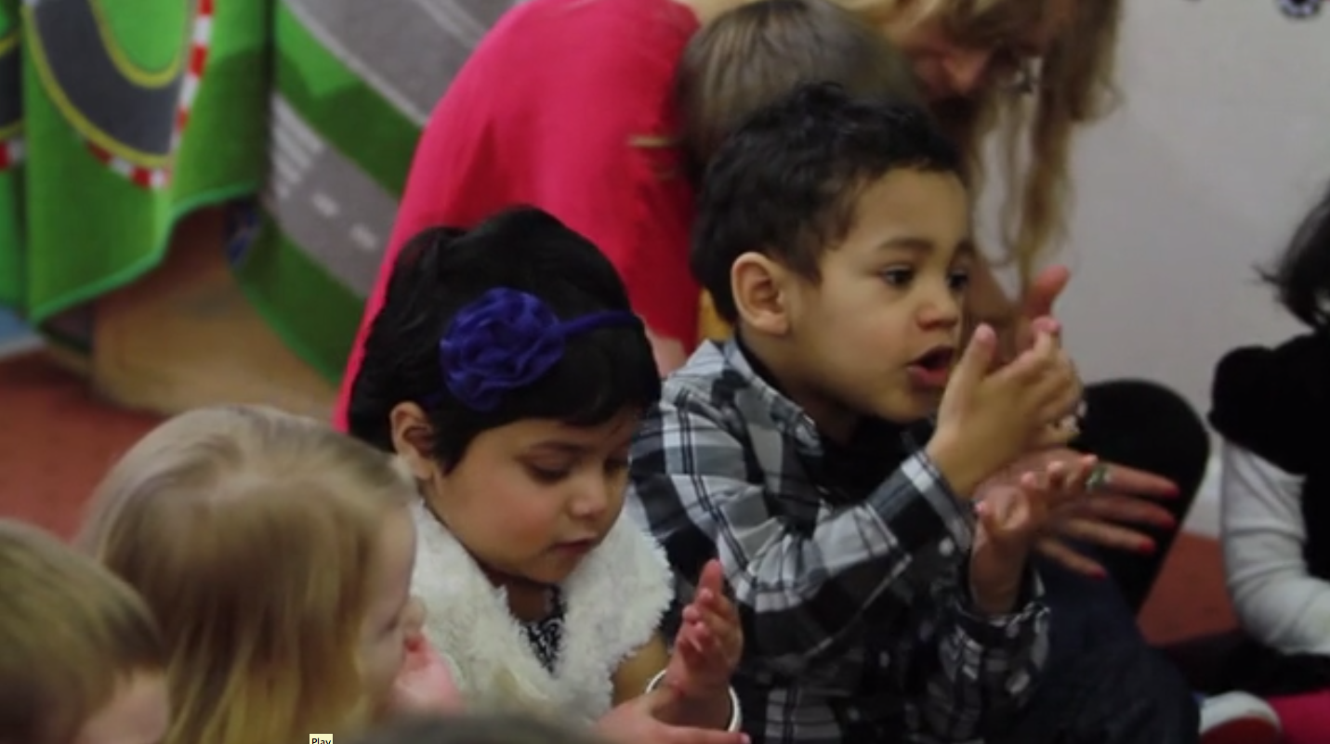

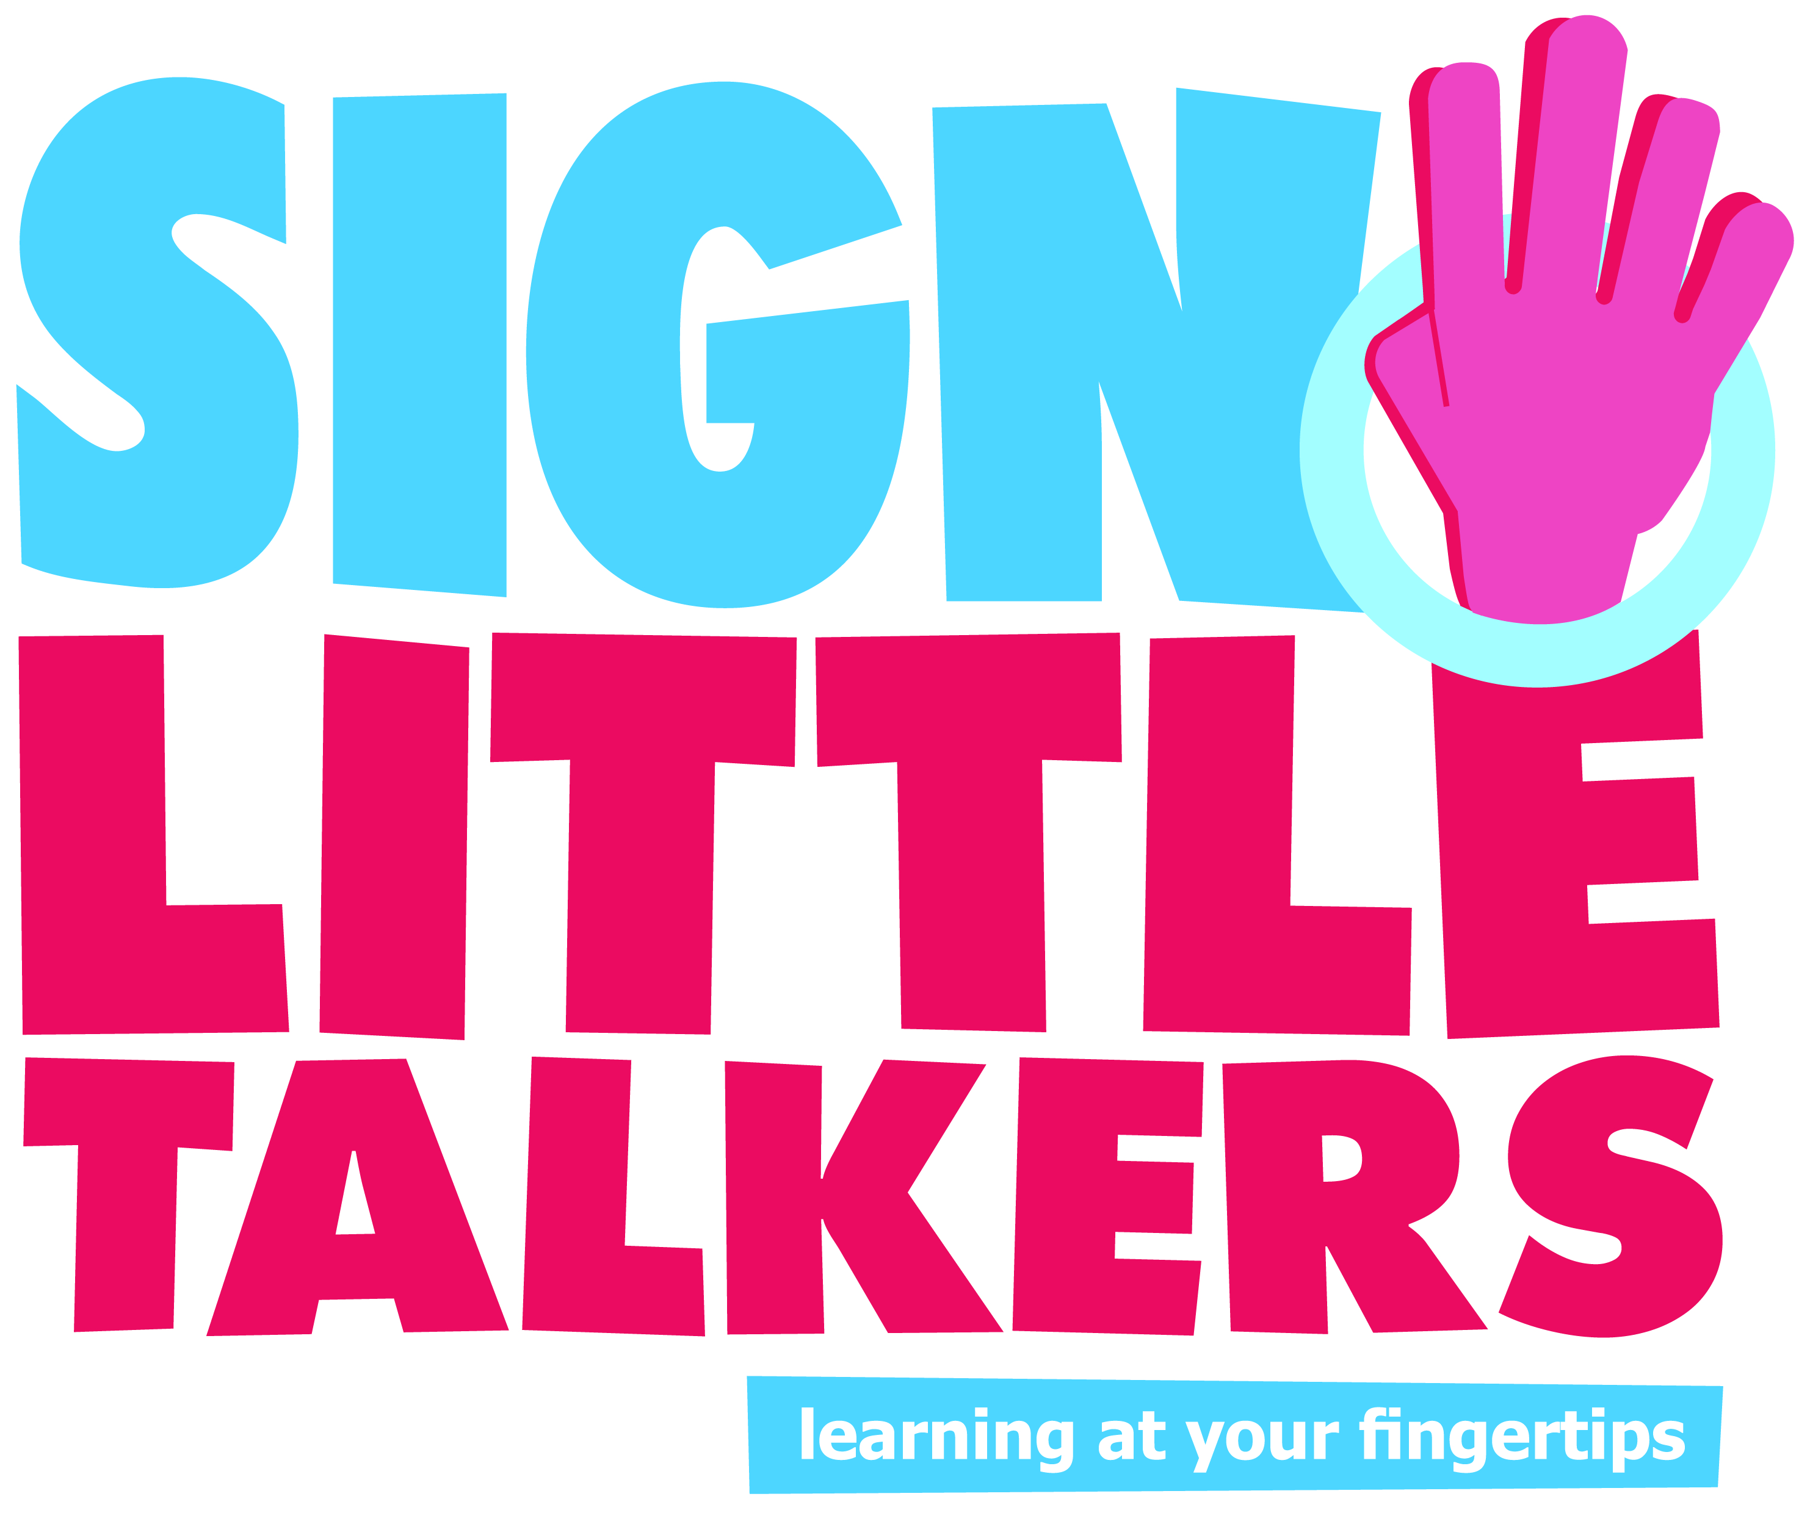

Why did we develop Sign 4 Little Talkers?
With the introduction of funded places for disadvantaged 2 year olds in nurseries and preschools and the subsequent rise in the number of 2 year olds in settings across Luton, it soon became clear that many children were entering settings with communication and language skills well below expected levels. These children were also unable to manage their feelings and behaviour in their new surroundings, which made the task for practitioners in these settings increasingly difficult as numbers of 2 year olds grew.

What did we want to achieve
Sign 4 Little Talkers was written and trialled in Luton with funding from Flying Start to support children, parents and practitioners in the following ways:
- To improve children’s communication and language skills and their ability to manage their feelings and behaviour as measured by Early Years Outcomes
- For parents to show a measurable increase in confidence to support their child’s communication and emotional literacy.
- For practitioners to show a measurable increase in confidence in supporting the emotional literacy, behaviour and communication of the two year olds in their settings.

How does it work?
- Sign 4 Little Talkers is a multi-sensory learning programme which supports the understanding and use of targeted vocabulary in young children
- Young children learn best when they are actively engaged and with Sign 4 Little Talkers they are not just hearing and saying new words but seeing and doing them as well.
Sign language also acts as an effective bridge joining understanding in home language, to English. Signing is a simple yet effective way to support speakers of the many and varied languages in Luton, as well as those with English as a first language, who may have a very restricted vocabulary

What did we do?
Flying Start funding enabled us to develop innovative new Sign 4 Little Talkers resources including five story books, three posters and a training DVD.
We then targeted those settings in Luton where children have the lowest outcomes in Language for Communication and Managing Feelings and Behaviour for ongoing support using these materials.
Research shows that young children learn best when they are actively engaged and with Sign 4 Little Talkers they are not just hearing and saying new words but seeing and doing them as well.
Key words were identified that children were not understanding and using, as outlined below. The Sign 4 Little Talkers materials encourage children to say as well as sign these key words.
The signed vocabulary for communication supports young children to talk about what happens in their lives and to understand and use words such as who, what, why, because and where.
The signed vocabulary for feelings supports children to understand and express the many emotions they experience each day, with words such as happy, sad, frustrated, worried and excited.
The signed vocabulary for behaviour supports practitioners, parents and carers to praise their children’s positive behaviour and to promote good manners, sharing and turn taking. Signed words include: please, thank you, calm down, gentle, wait, kind, your turn and listen.
The signed vocabulary for narrative supports children to understand and use sequencing and connective vocabulary such as: first, next, finally, at that moment, after that, until, suddenly and unfortunately.

What happened in the settings?
From 2013-2016 a total of seven settings were piloted and data collected from 202 children in total.
Settings were provided with Sign 4 Little Talkers materials, a training session for practitioners and ongoing support from a signing trainer.
Baseline and impact data was recorded to measure the attainment and progress of children and the confidence levels of the practitioners and parents.

In 2014-16 the project was developed to include training packages for parents and the provision of an electronic system for recording children’s progress and attainment for those who did not already have this.
Data was collected to measure children’s progress and attainment in EYFS Communication and Language and Managing Feelings and Behaviour.

What was the impact?
The progress our children have made is amazing, their vocabulary and confidence has grown. They are able to express how they are feeling and use more complex words to convey their thoughts and ideas. Using signs and the dolls during the story session has also improved the children's concentration and encouraged them to participate actively. Parents are also engaged and are spending more time reading and talking with their children. NURSERY MANAGER

Staff support children's development of English very well. Recent training in sign language enables staff to find differing ways to support children. As a result, all children make good progress in their communication and language. OFSTED

Additional Ofsted inspections for settings using the Sign 4 learning approach:

May 2016 – Ofsted Outstanding
Quality of teaching, learning and assessment is outstanding
Staff use signs with all children. This helps to support children's ability to understand and be understood by their classmates.

April 2016 – Ofsted Outstanding

The children behave very well. One of the behaviour management strategies the nursery uses is sign language for feelings to help children manage their emotions. Staff embed this by using sign language at book and rhyme sessions at various points in the day which the children enjoy joining in with.

I have found this really useful and the signs help my child with listening. I have also found it helps him a lot with his speech. We use signs at home and I found they really help when he gets frustrated or angry. The signs help to calm him down. PARENT

Sign 4 Little Talkers resulted in a measurable positive impact on children’s communication and language skills as well as their ability to manage their feelings and behaviour over a period of between one and two terms, with the percentage of children at or above expected levels at the end of the project generally exceeding those below expected levels.
Where children ended the project below expected levels their data showed that they made accelerated progress from their starting points and were effectively catching up with their peers.
Staff and practitioner confidence levels in using signing to support communication and emotional literacy increased significantly during the period following the training, suggesting that the signing with children had been practiced regularly.

What next?
Sign 4 Little Talkers will continue to be supported by Flying Start and the children tracked through to the end of the Foundation Stage to monitor longer term impact.
The research project continues and will now be monitored for impact by the University of Bedfordshire. Eight new settings have been identified for targeted support in 2016-17

