What is the pelvic floor?

The pelvic floor is the layer of muscles at the base of your pelvis that support your pelvic organs, bladder and womb, and control the passage of urine. It is in a sling shape from the pubic bone at the front to the bone at the bottom of your spine.
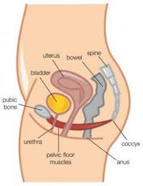

The pelvic floor muscles usually work without us having to think about it, for example, to stop us passing urine.

Why should I exercise my pelvic floor muscles?

You should exercise your pelvic floor muscles, because they become weak or damaged like any other muscles. If this happens, the muscle will not work properly and you may leak urine.

How do I know which muscle to exercise?

If you don’t know where your pelvic floor is, you can find it by imagining you are going to the toilet and are trying to stop yourself, or you can put your fingers into your vagina and try to squeeze around them. The muscles you use to do this are your pelvic floor muscles.

How do I exercise the muscles?

You must do fast and slow exercises to make your pelvic floor muscles stronger.

Slow Exercises

You should sit or stand comfortably with your knees slightly apart. Try to squeeze as if you are trying not to pass wind and also squeeze the muscles around your urethra, as if you are trying not to pass urine. Do not use your tummy muscles or your bottom when you are doing this exercise.

When you can do this, squeeze them together, as tight as you can, and hold for as long as you can, up to ten seconds. You may not be able to hold it for more that two or three seconds at first. Repeat this as often as you can, up to ten times, but have a rest in between each one for four or five seconds.

Fast Exercises

Fast exercises are done in the same way as the slow exercises but, when you squeeze the muscles, let go immediately so that you only feel a quick lift in your pelvic floor. You should repeat these exercises as many times as possible up to ten times.

You should do both fast and slow exercises at least four times a day but up to ten times a day if you can. Do not do so many exercises that the muscles ache!

If you need any more help, you should contact your local continence service.

