Does your child or a child you work with have a diagnosis of Selective Mutism? Maybe they talk normally at home but not at school or with unfamiliar adults?

**When someone speaks to me I get very tense and panicky. My mum says I look like a rabbit in headlights**

**SMARTI**

**Selective Mutism Support Group**

(Selective Mutism Resources, Training and Information)

For more information, please contact Gold Coker at the Special Educational Needs Service (SENS) on 548151

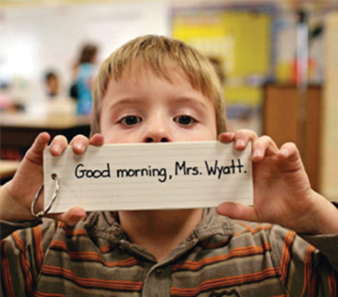

Join us for our next meetings on:

**Tuesday 15th October 2019 9.30-11am**

**Tuesday 11th February 2020 9.30-11am**

**Tuesday 12th May 2020 9.30-11am**

**At St Joseph’s Primary School**

**Gardenia Avenue, Luton LU3 2NS**

Would you like to learn more about this difficulty and meet others in the same situation as you?